**DIRECTORS' REPORT**

On behalf of the Directors of Kohinoor Spinning Mills Limited, it is my pleasure to present three months accounts for the period ended 30th September 2015.

Your Company has incurred a net loss of Rs.3 7 million as compared to a net profit of Rs.

15 million for the corresponding period last year. Ever fluctuating cotton prices, rise in electricity prices, imposition of GIDC and less availability of electricity as compared to the corresponding period last year are main causes of this adverse result.

Sales have reduced from Rs. 1.5 billion in 2014 to Rs. 1.3 billion in the current period (a decrease of 13%). Sales were reduced mainly due to decrease in cotton prices resulting in lower yam prices and lower quantity of yam sold due to less available fuel and power. Similarly, gross profit has registered 3% reduction as compared to the corresponding period last year (i.e. from 11 % in 2014 to 8% in 2015). The slide in yam prices was manifold as compared to slide in cotton prices during the year under review.

The future outlook of spinning industry depends on factors like rising export demand, continuous electricity and gas supply and consistent monetary policy by State Bank of Pakistan (SBP). The export market is dormant these days. Far East buyers are least interested in buying yam at reasonable rates. If we want a strong industrial base, we need to rationalize our energy rates and ensure non-stop fuel and energy supply to give a competitive edge to our products. SBP should not increase bench mark interest rate in next monetary policy. We are of the opinion that low interest rate is a must for industrial growth.

In the end, I assure you that the management will continue its efforts to improve the overall performance of the Company through increased productivity, cost control and by devising optimal production strategies.



**Lahore:**

**13 January 2015**

*<!./*�

**lVlo**�**;veed**

**(Chief Executive)**

'- r :,1 C') "U 0 *(/)* )> --; C') 0 *(/)* r r z *(/)* )> *en* )> (/) m

Ql Ql 0 0 c *:::T* (") tu c (1) c iii" 0 0 c o "' c *::r D*

::, *:::T* "' 0 o i'D' "O ::, *CT* o c *=r* A>

c 0 "' z

*u*<*;·*

iii ::;:. 2 a. ;u

:::; -g

g tO z 6 c (1) (D c

Ql � § --;

;:?.

(1) ;u

"" ro

0 3 w a. w 0 ::j

-�< z 6 ro

(1)

a. Ql

m (1) (1)

z

"' 3 c 5· iii"

ii," a. c

0 0 �·

C') -<

"' ::, "O 3 ::,

0 0

a. -,_ ·o "' 0 (1) A>

w x G) 0 :, a. "' ;u 0 c 0 a. )>

m *Q* ;:i

--;

iii" Ql

Ql ro 0 *CT* 0

"O z

"a'. z 5· *CT*

ro 0 r

o tO r ;u ro

a. 8 "' 0 0 �

"�'

::,

*Q* ro :T

s � ro Ql 0 m

a. Q 0 Ql 0

0 Q iii ::, � g 5· Ql z "O -s1.

A> r

0) *ii,* m

!!!.

� :;;

"O r "' "' Ql

c ..

x 0 � OJ ii," � ::, --; 0 0 '- fr 'c-: [ >

0 ;:$ :, (1) :, ::,

"' (/)

6" ::, 5 ::, Ql *Q* Ql

r ::, 11) a. c.

> OJ

...

"' w

*CT* i'ii tO

(1) OJ a

::,

re

(1) =

"' ::!

0 )> ::, 0 to 0 Ql "'

*en* r

o

"' ."o'

;:! z

::,

-c ::j "'

.o Ql ;u

a.

0 e; ::, iii (/) tu

Ql c m �- i:i (/)

3 ':1 "O ':1

"(1')

"::,' C') iil *in* "' c "' ::j a. "' Ql "' < m

9 0 a ::, � *s:* w w (1)

*ii,* 3:

a. (1) (/) Q. 0 c .o "'

oe 3: iii" *CT* Q. 0 0 "O 8

Ql .o

� ::j

Q: *Q*

0 cil _8 (")

-0 3: "" 0:;;

m ii,"

0

::,, *9*

-s1. 8

*9*

z 5·

; "'

--; tO

::, [

Ql 0 0

::, 5·

a

s

a

Q.,

(/) *v,*

5

-"<'

-"<'

s- iii � �

Ql CJ

"' *v,* "'

.C,J

(1) m m

9 2. 2.

*i*..*i*.*,* � �

"..' "(1)'

§"

n � "'

0

::, a. "::,'

"a'.

CJ 9-

z

0

? ro

"::',

n

0) "' z

[ (/) --;

(1) m

C')

",:;';- ;u

¥

@

*ii,* c 3:

... w

� ... ... ...... ... en en

� 3 ::,

9 00

\

"::',

... en ... ... u, *<D* N � ... 0 u, 0, 0, c CT > 0

0 � *<D* en 00 N -� 0, 0 0 0, 0 0 "O (.1..) c

0

� 00 � � 0 �... i,, in 00 *<O*

0 0

...

0 w 0 0 (1)

... sc. z

� 00

... ... 00 0 �

(1)

_o

0 -°' N _ en

...... *<D* en en

0..0. 00 00 _

0 0 0 .!!!.

N *<D* N

... 0, 0 *<D* 0 0

m

c. z

0

m

0 ��

00 in

� *<*�*D*

...... 0 w -...... 00 � 0 ... ·"..'. 0 0

N... *en*

00 0, 0

*<D* en

*<D* N N 0 0 0

0, 0

OJ ;,,;;

)> 0

r ::i:

)> z

-�"' �

(JI

... ...

...

z

C') 0

� ::, )> m ;u

� "' c.n *w* ..... 0) 0) (1) 0

'c-

co

-"'

(1) _o

...

"O ...

::i: (/)

*.i,,.*

*w*

.....

*.i,,.* �

.....

c.n

0 (0 c.n c.n c c (/)

......

*w* (0

(...)

*w* _.i,,.

N 0,

.c.n 0 0 0

..... 0 *w* Cl 0

m

� m "O

c.n *.i,,.* Cl "' co (0 0 *.i,,.* _o 0

� --; z

*.i,,.* 0 Cl

(0

c.n

.....

0 *w .i,,.*

0 0 0 O·

(1)

.!!!. N

(1)

c.

:....... .c"o' 0, *'.i.* (...) co 0, Cl Cl co 0 Cl )> z

·."..'

c.n c.n 0 Cl 0) ..... 0 *w* 0 0 0, (/)

Cl c.n

*w w* "'

(0 (0

..... 0 co 0 0

--; 3:

)> G)

(/) r

0 --; r --; *(/) (/)* C') r r r "O z )> m r

Ql w 0 tu 0 0 c

"O *en*

::, ::, ::, --;

0 0 0 0 0 (/)

"*:::*'*T*

Ql

::,

a.

(1)

::, a. (�") iil ;u

Ql a. 5· m

tO tO tO "O z

ro ro ro (1)

c

(/)

m

m r

3: 3:

Ql a.

(1)

"Q'l z

0 --;

(/)

(1)

OJ ::j

a. "O ::,

"' (1) ;u

(1)

.!.. ::,

3 3 3

� ;u m m

0 a.

Ql

*eCnT*

a. a. --; .;.u.

*CT* "' Ql tu

5· a. r "O ;u 0

::, -�

a. (I) ""O' )>

< (I) 0 iii m

*7<"* < Ql (/) (I) u Ql a z *9*

Ql

"' --;

*CT* "*-:*'*:,*

::, iil

*en* 0 ::,

m 3 "' "' ...

Ql 0 (") "' �

"'

A> )> 0

iii" ;::i. (I) --; (1) ::, *en*

::, ro

3

(/) ::, c.

(/) 0,

(")

(1)

"'

*en* (1) m

c --; z

.c c

ro

"O -5· *en* >

"O 3 c

Ql (1) 0

'< a

3 ::j (1) m in .9 w

::,

::,

a.

st

*-::,*

�

ro

0

(1)

w<" z

CroT i

"' co "'

:;! ... ...

(/)

(1)

"rOo c

N � 3 ::,

en

� � 0, 0, N 00 ... ...

0 c: CT >

... � *<D* ...... 0, _... 0 0

0, "O � c

"' "' � � in

*<O* � i,,

00 � (1) ... �

00 0, 00 0, en N *<D* � *<D* ...., N .!!!. _o ro

en ...... 0 *<D* 00 _...

...... _o 00

�

... c.

i,, in "' � *<O* "' *<O* w � :... N

*<D* en 00 0 0

... 0,

en ... ...

u, N

� 0 0, 00 en en *<D* N *<D* 0,

'c-:

c.n ... *.i,,.* Cl (0 *.i,,.* (0 *w* ... co c: ... c

*_w* 0 _.i,,. ..... c.n

"' "'

"'..._i

...

_o c.n "O

co *w* w C"'l � ::, )>

*'.i.* c.n c.n

(1)

_o c.

*w* ... ..... c.n *.i,,. w* ...l c.n (1) N �

"'

c.

0, *'.i.*

(...)

0, (1)

...

...... .....

..... co

(])

*.i,,.* "' .c.n

(]) ..... ..... ..... "'

..... .!!!. �

*·w* 0,

"'

*'.i.* -"' N N (...) *'.i.*

"'

0,

*.i,,.* (]) 0

"'

0) "*w*' *.i,,.*

(0 0 0)

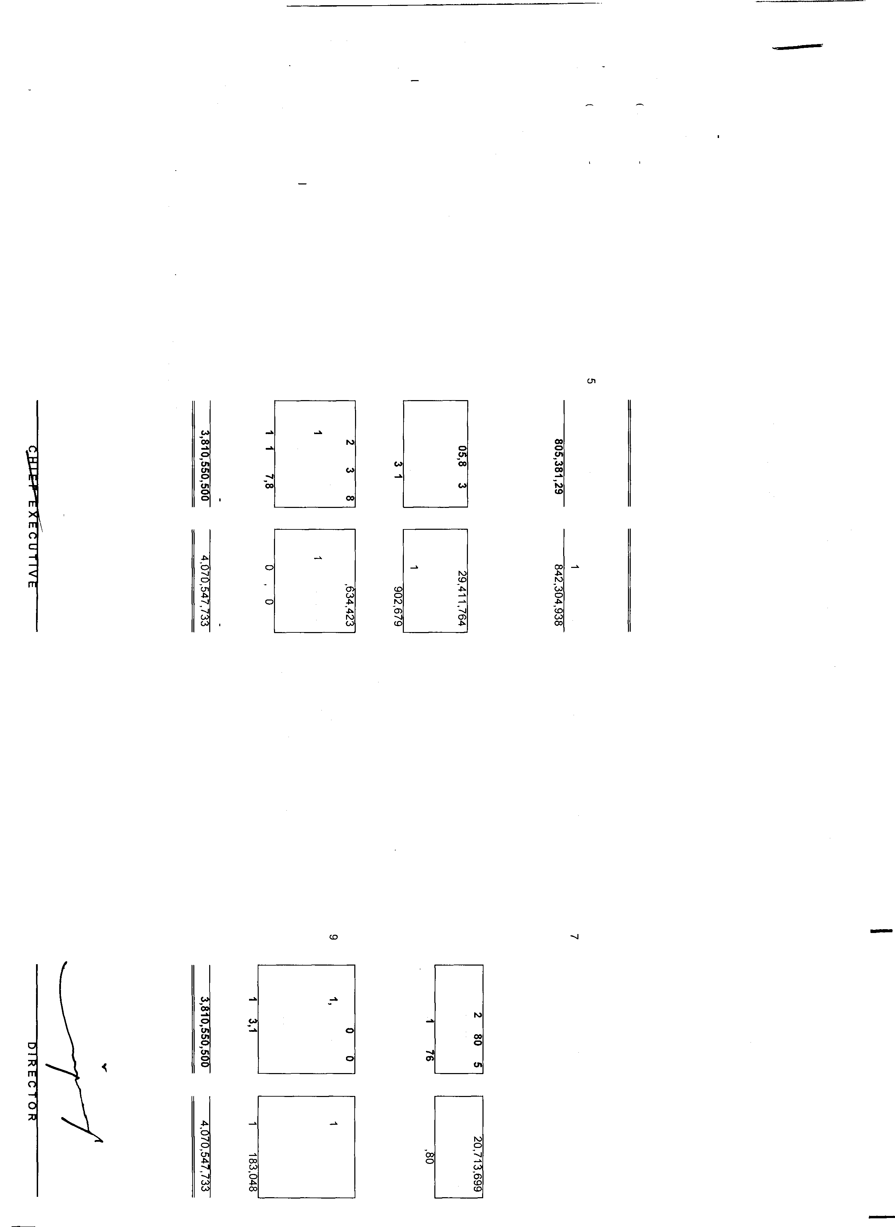

c.n *.i,,.* "'

KOHINOOR SPINNING MILLS LIMITED

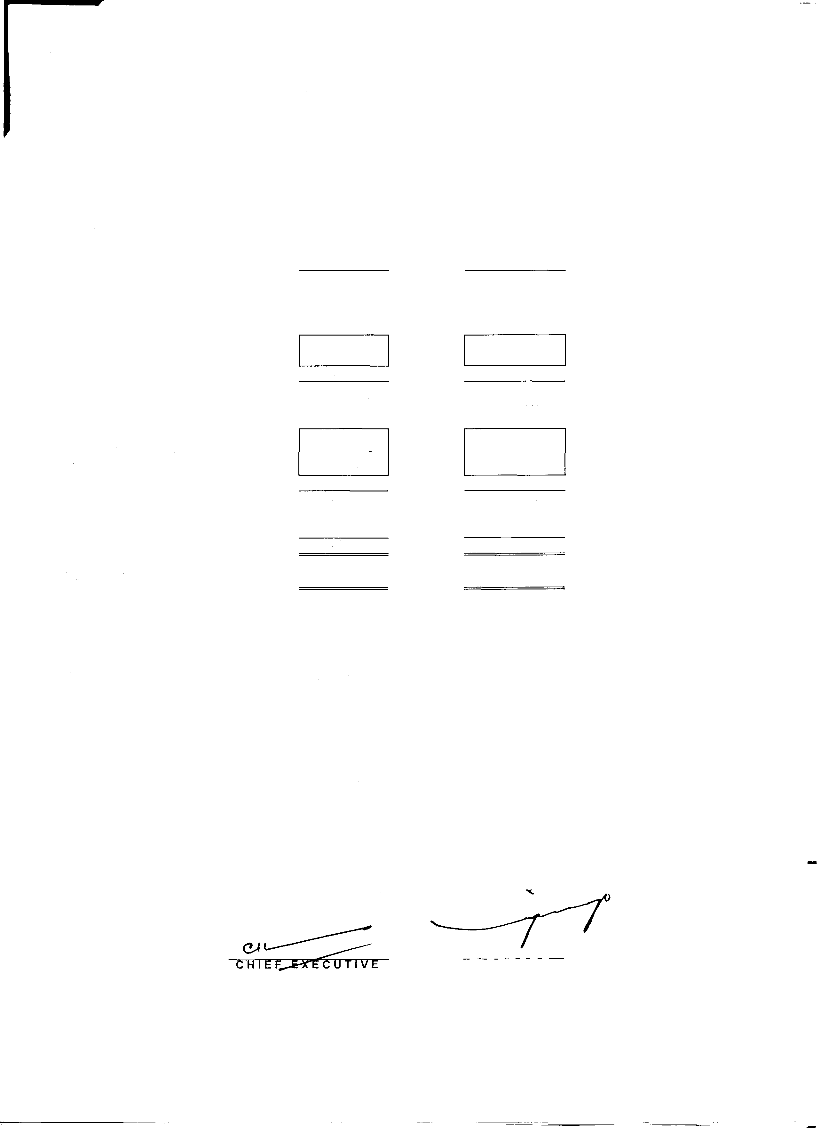

INTERIM CONDENSED PROFIT AND LOSS ACCOUNT (UN-AUDITED) FOR THE PERIOD ENDED SEPTEMBER 30, 2015

|  |  |  |
| --- | --- | --- |
| Notes | September 30, | September 30, |
|  | 2015  (Rupees) | 2014 (Rupees) |

SALES - NET 1,257,406,778 1,505,595, 119

|  |  |  |  |
| --- | --- | --- | --- |
| COST OF SALES | 10 | (1, 155,960,305) | (1,333,784,978) |
| GROSS PROFIT |  | 101,446,473 | 171,810,141 |
| OPERATING EXPENSES |  |  |  |
| Distribution Cost |  | (30,537,731) | (32,320,727) |
| Administrative |  | (40,780,224) | (39,947,997) |
|  |  | (71,317,955) | (72,268,724) |
| OPERATING PROFIT |  | 30,128,518 | 99,541,417 |
| Financial cost  Other operating expense |  | (57,779,535) | (68,314,259) (1,S82,482) |
| Other operating income |  | 3,334,704 | 422,472 |
|  |  | (54,444,831) | (69,474,269) |
| (LOSS)/PROFIT BEFORE TAXATION |  | (24,316,313) | 30,067,148 |
| TAXATION | 11 | (12,574,068) | (15,055,951) |
| (LOSS)/PROFIT AFTER TAXATION |  | (36,890,381) | 15,011, 197 |
| (LOSS)/PROFIT PER SHARE - BASIC | 12 | (0.28) | 0.12 |

The annexed notes form an integral part of these interim condensed financial statements.

Lahore,

January 13, 2016 DIRECTOR

------------ ---·-

KOHINOOR SPINNING MILLS LIMITED

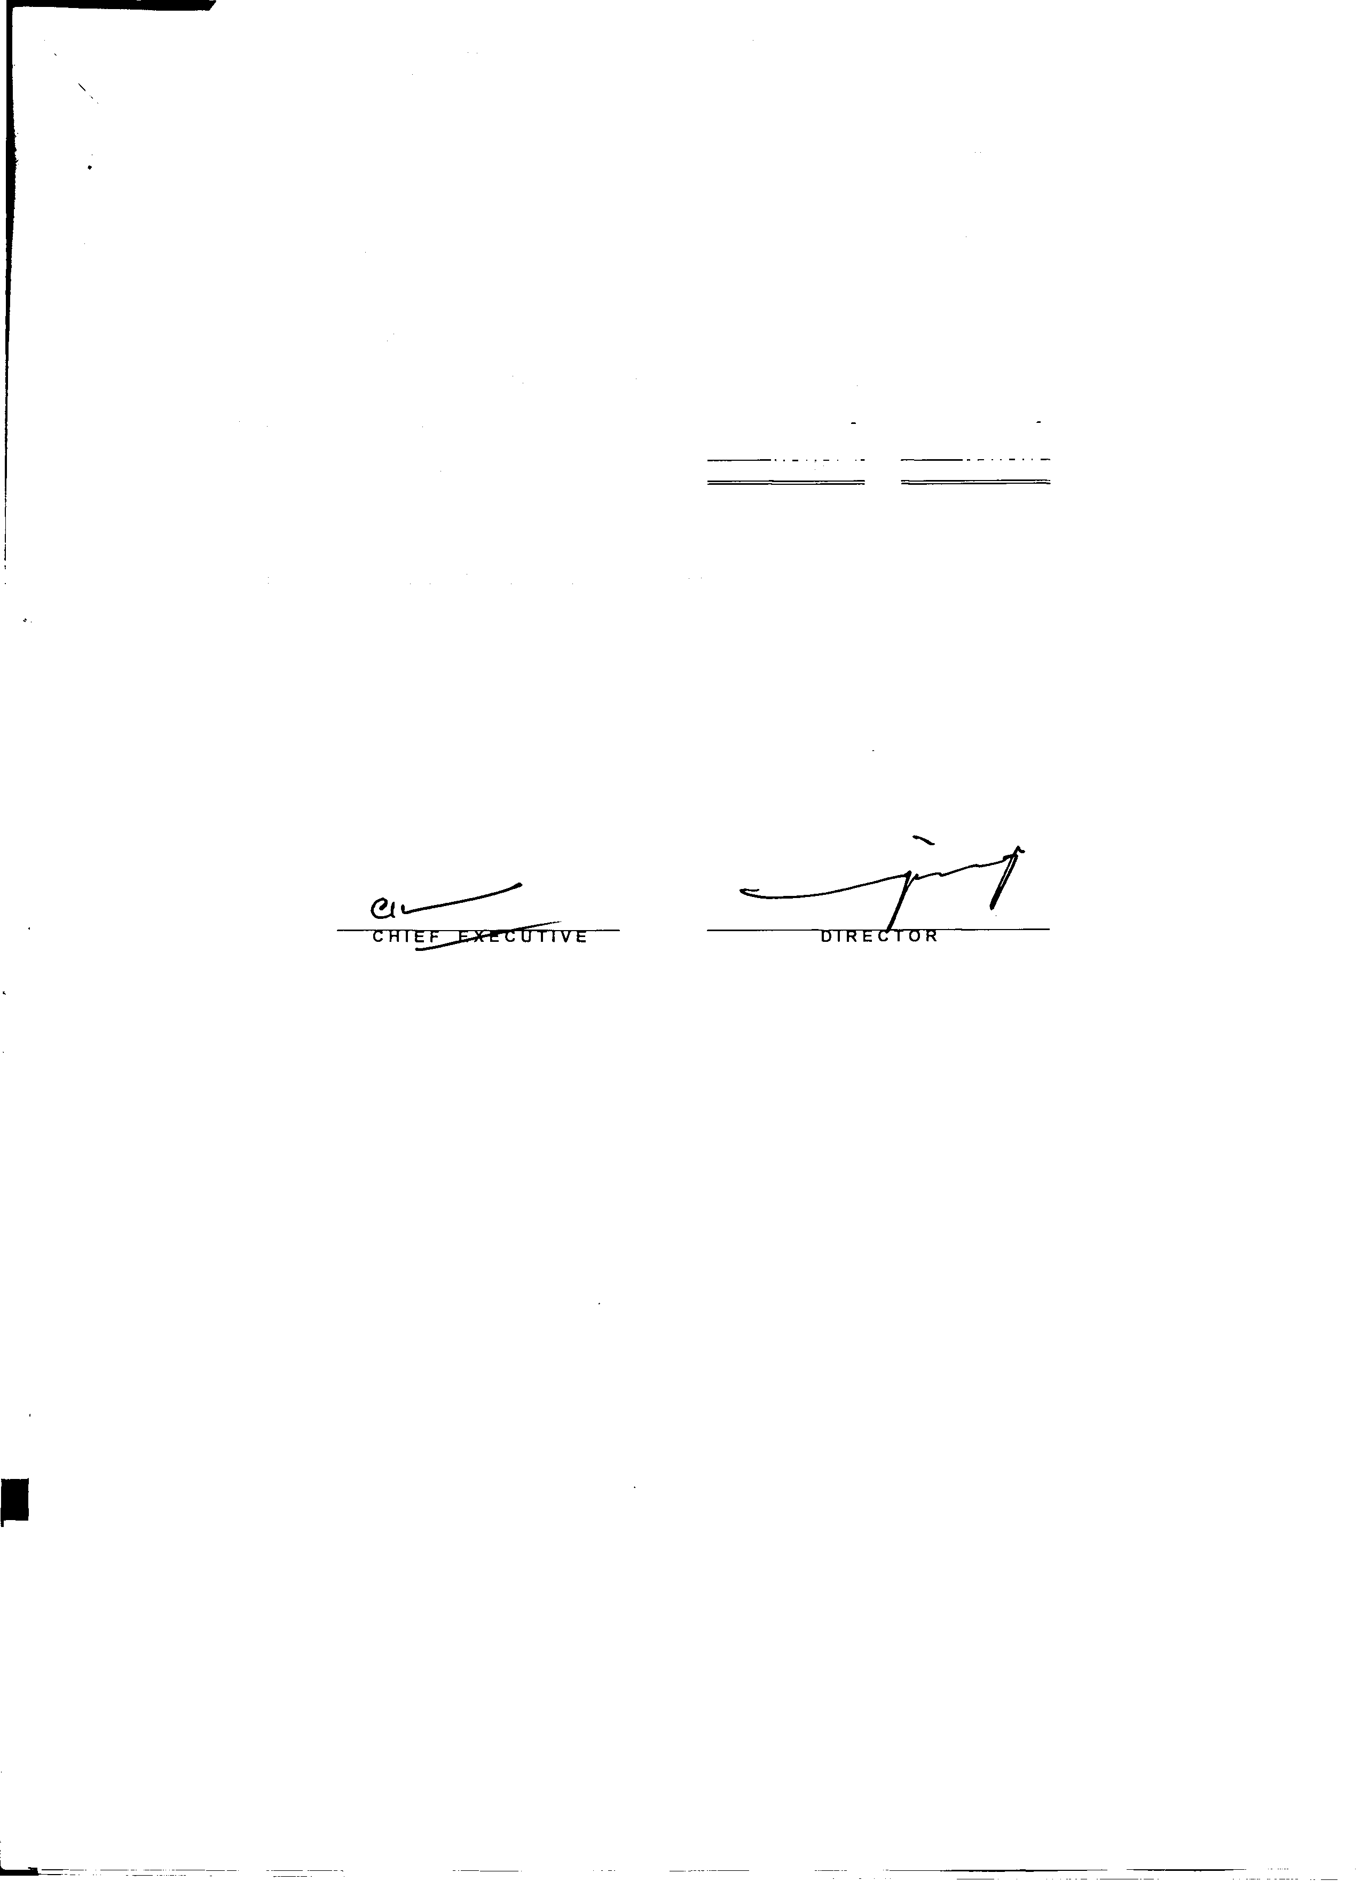

INTERIM CONDENSED STATEMENT OF COMPREHENSIVE INCOME (UN-AUDITED)

FOR THE PERIOD ENDED SEPTEMBER 30, 2015

|  |  |  |
| --- | --- | --- |
|  | Un-Audited septemeer JU, :LU1:, | Un-Audited  :septemoer ;.iu, :LU14 |
| (Rupees) | (Rupees) |
| (Loss)/profrt after taxation | (36,890,381) | 15,011,197 |
| Other comprehensive Income |  |  |
| Items that may be reclassified subsequently to profit and loss |  |  |
| Unrelized (loss) due to change in fair value of long term investment | (33,263) | (124,741) |
| Items that will not reclassified to profit and loss |  |  |
| Totalcomprehensive Income for period | (36,923,644) | 14,886,456 |

The annexed notes form an integral part of these interim condensed financial statements.

Lahore,

January 13, 2016

-

KOHINOOR SPINNING MILLS LIMITED

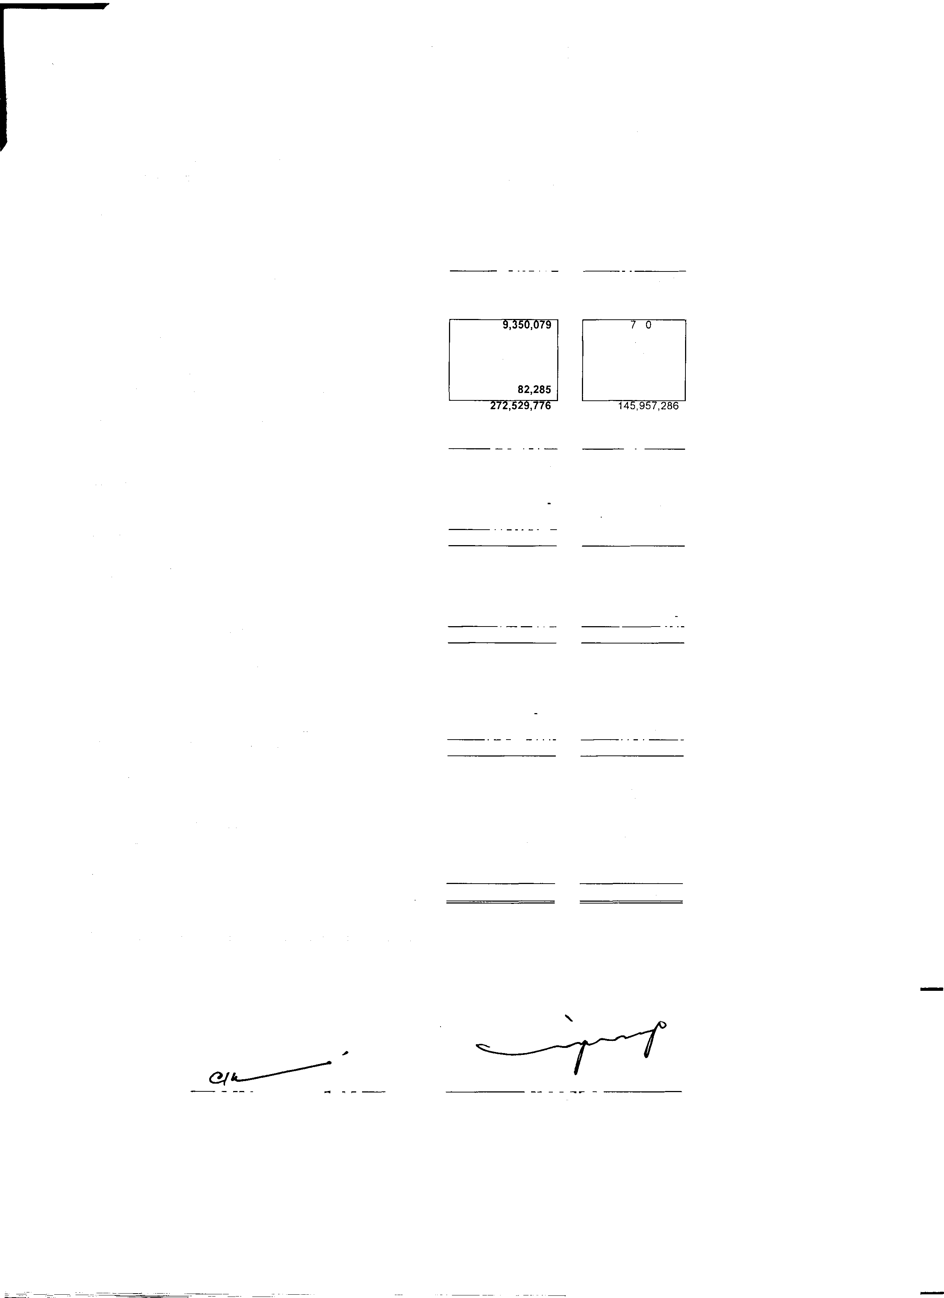

INTERIM CONDENSED CASH FLOW STATEMENT (UN-AUDITED) FOR THE PERIOD ENDED SEPTEMBER 30, 2015

|  |  |
| --- | --- |
| Un-Audited  September 30, 2015 | Un-Audited  September 30, 2014 |
| (Rupees) | (Rupees) |
| CASH FLOW FROM OPERATING ACTIVITIES |  |
| (Loss)/Profit before taxation (24,316,313) | 30,067, 148 |
| Adjustments of non cash charges and other items: |  |
| Depreciation *I* amortization 27,381,752 | 23,420,994 |
| Gratuity 11, 166,969 | 9,828,483 |
| Financial cost 57,779,535 | 68,314,259 |
| Operating profit before working capital changes 72,011,943 | 131,630,884 |
| (lncrease)/decrease in current assets |  |
| Stores and spares | 1 ,1 4,001 |
| Stock-in-trade 219,734,070 | 154,978,011 |
| Trade debts 35,007,572 | 3,439,215 |
| Loan & advances 8,355,770 | (15,270,303) |
| Trade deposits, prepayments & other receivables | (14,293,638) |
| Decrease/increase in current liabilities |  |
| Trade and other payables 20,901,655 | (104,856,332) |
| 365,443,374 | 172,731,838 |
| Financial cost paid (62,563, 107) | (70,310,141) |
| Income tax paid (11,372,908) | (12,821,959) |
| Dividend paid | (1,260) |
| Gratuity paid (3,388, 173)  Net cash used in operations 28S,119,1M | (4,554,655)  ---8-s--� |
| CASH FLOW FROM INVESTING ACTIVITIES |  |
| Fixed capital expenditures (16,949,986) | (60,540,450) |
| Long term loans (166,766) | 221,637 |
| Proceeds from disposal property, plant and equipment 9,702,514 |  |
| Net cash used in investing activities (7,414,2311) | (60,318,813) · |
| CASH FLOW FROM FINANCING ACTIVITIES |  |
| (Repayments)/proceeds from: |  |
| Decrease in finance lease liabilities (6,839,869) | (8,502,208) |
| Decrease in supplier's credit | (82, 165,666) |
| Decrease/Increase in short term borrowings (241,331,759) | 61,834,013 |
| Net cash generated from financing activities l24s,m.s2s) | (;'.i!l,833,862) |
| NET INCREASE/DECREASE IN CASH AND |  |
| CASH EQUIVALENTS 32,533,321 | (4, 108,850) |
| CASH AND CASH EQUIVALENTS AT |  |
| THE BEGINNING OF THE PERIOD 10,724,341 | 10,910,082 |
| CASH AND CASH EQUIVALENTS AT |  |
| THE END OF THE PERIOD 43,257,662 | 6,801,232 |
| The annexed notes form an integral part of these interim condensed financial statements. |  |

Lahore,

January 13, 2016 CAIE�r'TVE DIRECIOR

KOHINOOR SPINNING MILLS LIMITED

INTERIM CONDENSED STATEMENT OF CHANGES IN EQUITY (UN-AUDITED) FOR THE PERIOD ENDED SEPTEMBER 30, 2015

Share Accumulated

Capital Profit Total

|  |  |  |
| --- | --- | --- |
| Rs. | Rs. | Rs. |
| 650,000,000 | 488,020,366 | 1, 138,020,366 |

Balance as at July 01, 2014

|  |  |  |  |
| --- | --- | --- | --- |
| Profit for the period after taxation | | 15,011,198 | 15,011,198 |
| Unrealized loss due to change in fair  Value of long tenn investment |  | (124,741) | (124,741) |
| Balance as on September 30, 2015 | 650,000,000 | 502,906,823 | 1, 152,906,823 |
| Balance as on July 01, 2015 | 650,000,000 | 192,304,938 | 842,304,938 |
| (Loss) for the period after taxation |  | (36,890,380) | (36,890,380) |
| Unrealised loss due to change in fair value *of* long term investment |  | (33,264) | (33,264) |
| Balance as on September 30, 2015 | 650,000,000 | 155,381,294 | 805,381,294 |

The annexed notes form an integral part of these interim condensed financial statements.

Lahore,

January 13, 2016

*(Z/*�

CHIEF-�E

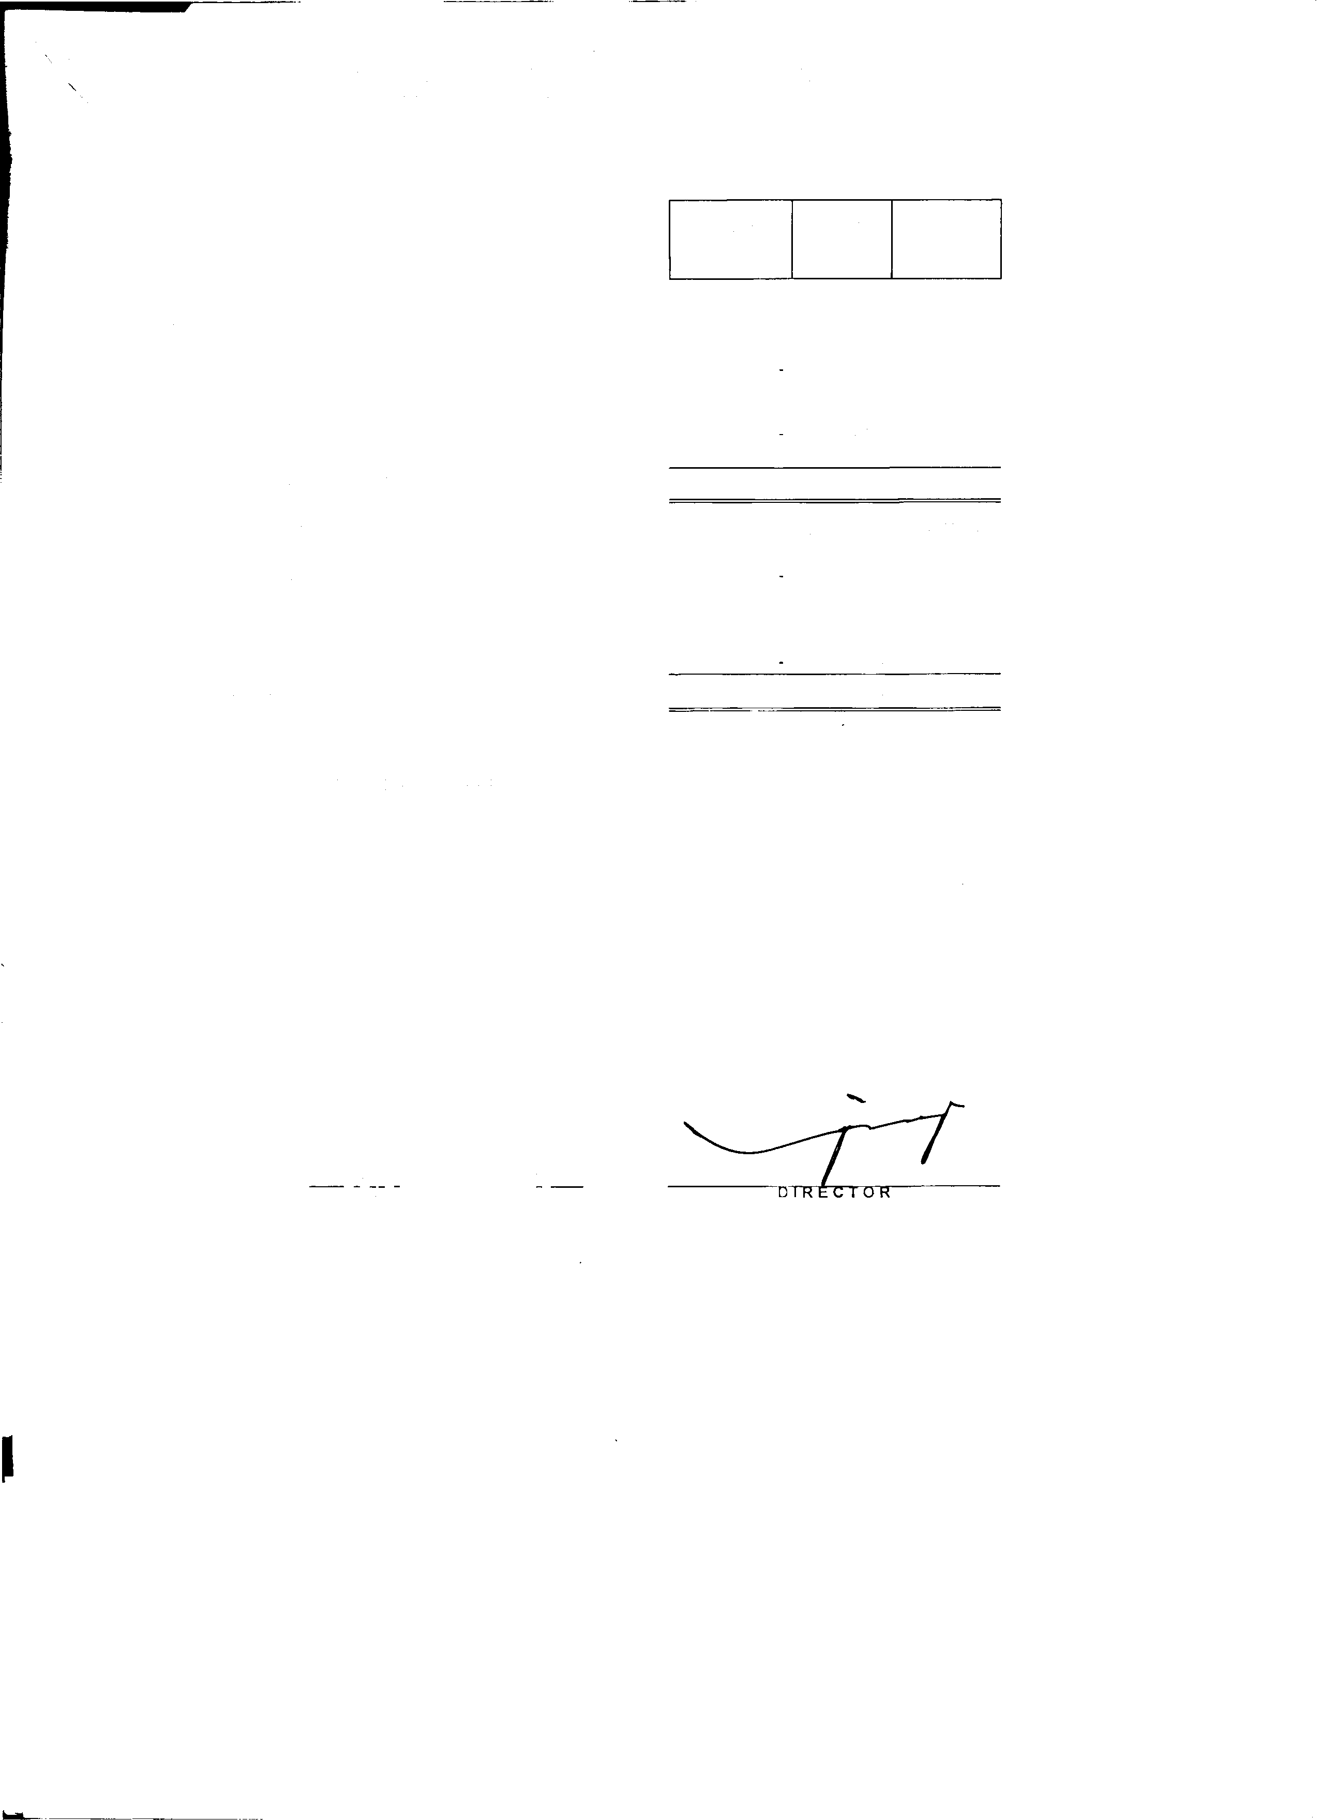

•

**KOHINOOR SPINNING MILLS LIMITED**

**NOTES TO THE INTERIM CONDENSED FINANCIAL STATEMENS (UN-AUDITED) FOR THE PERIOD ENDED SEPTEMBER** 30, **2015**

1. NATURE AND STATUS OF BUSINESS

KOHINOOR SPINNING MILLS LIMITED was incorporated on 23rd July, 1970 as a public limited company in Pakistan under the Companies Ordinance. 1984 and is quoted on Karachi stock exchange. The registered office of the company is situated at 7/1, E-3, Main Boulevard Gulberg 111, Lahore. The company is engaged in the business of textile spinning

2. BASIS OF PRESENATION

This interim condensed financial statement is unaudited and are being submitted to the shareholders as required under section 245 of the Companies Ordinance, 1984. These interim condensed financial statements has been prepared in accordance with the International Accounting Standard 34 (Interim Financial Reporting). In case where requirment differ. the provisions of or directives issued under the Companies Ordinance, 1984 have been followed. These condensed interim financial statements should be read in conjunction with the audited annual published Financial statements of the company for the year ended June 30, 2015.

3. SIGNIFICANT ACCOUNTING POLICIES

The accounting policies and the the methods of computation adopted in the preparation of this condensed interim financial information are the same as those applied in the preparation of the preceding annual published financial statemends of the company for the year ended June 30, 2015.

4.

4.1

4.2

ACCOUNTING ESTIMATES, JUDGEMENTS AND FINANCIAL RISK MANAGEMENT

The preparation of this condensed interim financial information in conformity with approved. accounting standards requires management to make estimates, assumptions and use judgements that affect the application of policies and reported amounts of assets and liabilites and income and expenses. Estimates, assumptions and judgements are continually evaluated and are based on historical experience and other factors, including reasonable expectations of future events. Revisions to accounting estimates are recognised prospectively commencing from the period of revision.

Judgments and estimates made by the management in the preparation of this condensed interim financal information are the same as those that were applied to the financial statements as at and for the year ended 30

June 2015.

The company's financial risk management objectives and policies are consistent with those disclosed in the financial statements as at and for the year ended 30 June 2015.

|  |  |  |  |
| --- | --- | --- | --- |
| 5. | SHARE CAPITAL | Un-Audited September 30, 2015 (Rupees) | Audited June 30, 2015 (Rupees) |
|  | Issued, subscribed and paid up |  |  |
|  | 127,725,000 (June 30, 2015 -127,725,000) ordinary shares of Rupees 5/- each, issued for cash | 638,625,000 | 638,625,000 |
|  | 2.275,000 (June 30, 2015 -2,275,000) ordinary shares of of Rupees 5/- each, issued as bonus shares | 11,375,000 | 11,375,000 |
|  |  | 650,000,000 | 650,000,000 |
| 6. | COMMITMENTS |  |  |
|  |  | Un-Audited | Audited |
|  |  | September 30, 2015 | June 30, 2015 |
|  |  | (Rupees) | (Rupees) |
|  | (i) Letter of credits for Import of raw material | 28.666 Million | 58. 771 Million |
|  | (ii) Letter of credits Machinary & Parts | 8.006 Million | 14.494 Million |



•

7. PROPERTY, PLANT AND EQUIPMENT

Un-Audited Audited

September 30, 2015 June 30, 2015

(Rupees) (Rupees)

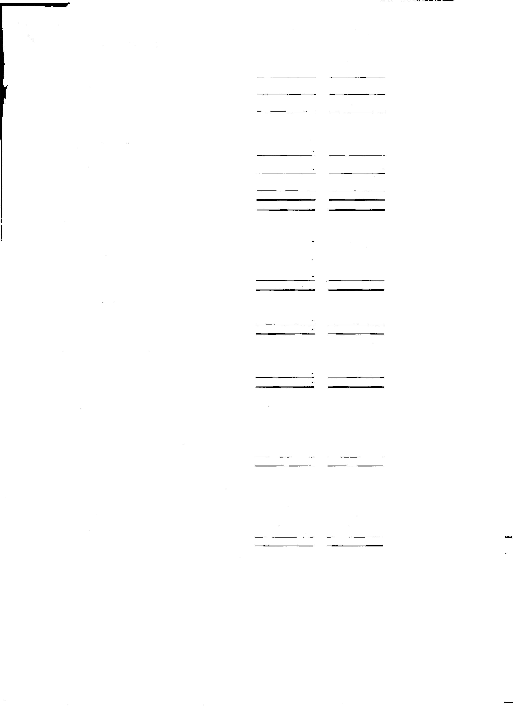

|  |  |  |  |
| --- | --- | --- | --- |
| Opening writtendown value |  | 1,994,965,644 | 1,608,864,505 |
| Additions/transfer during the period | 7.1 | 16,949,985 | 488,470,824 |
|  |  | 2,011,915,629 | 2.097,335,329 |
| Deletion/transfer during the period | 7.2 | (9,702,516) | (8,386,084) |
|  |  | 2,002,213,113 | 2,088,949,244 |
| Depreciation charged during the period |  | (25,599, 150) | (93,983,600) |
| LEASED |  | 1,976,613,963 | 1,994,965,644 |

|  |  |  |  |
| --- | --- | --- | --- |
|  | Opening writtendown value | 90,591,778 | 92,725,673 |
| Additions/transfer during the period 7.3 |  | 4,762,500 |
|  | 90,591,778 | 97,488,173 |
| Deletion/transfer during the period |  |  |
|  | 90,591,778 | 97,488, 173 |
| Amortization charged during the period | (1, 782,602) | (6,896,395) |
|  | 88,809, 176 | 90,591,778 |
|  | 2,065,423, 139 | 2,085,557,422 |
| 7.1 | ADDITIONS/TRANSFER DURING THE PERIOD |  |  |
|  | Factory building on freehold land |  | 219,233,637 |
|  | Plant and machinary | 16,774,485 | 259,397,986 |
|  | Electric installation |  | 1,726,676 |
|  | Office equipment | 175,500 | 601,976 |
|  | Vehicles |  | 7,510,550 |
|  |  | 16,949,985 | 488,470,824 |
| 7.2 | DELETION/TRANSFER DURING THE PERIOD |  |  |
|  | Vehicles |  | 8,386.084 |
|  |  |  | 8,386,084 |
| 7.3 | DELETION/TRANSFER DURING THE PERIOD |  |  |
|  | Vehicles |  | 4,762,500 |
|  |  |  | 4,762,500 |
| 8. | LONG TERM INVESTMENTS | Un-Audited | Audited |
|  | Held as available for sale | September 30, 2015 | June 30, 2015 |
|  |  | (Rupees) | (Rupees) |
|  | Others - Quoted |  |  |
|  | KASS Modaraba (Former First Mehran Modaraba) |  |  |
|  | 166,320 modaraba certificates | 498,959 | 532,223 |
|  | of Rupees 1 O each. | 498,959 | 532,223 |
| 9. | STOCK-IN-TRADE |  |  |
|  | Raw material | 744,791,394 | 920,609,685 |
|  | Work-in-process | 126,413,899 | 138,645,953 |
|  | Finished goods | 250, 196, 146 | 280,053,044 |
|  | Waste | 4,221,699 | 6,048,525 |
|  |  | 1,125,623,138 | 1,345,357,207 |

**liiiiiiiii...iiiiiiiiiiiiiiiiiiiiiiii;;;;;;;;;;==========------------···**�**--··**

'

13. TRANSACTION WITH RELATED PARTIES

|  |  |  |  |
| --- | --- | --- | --- |
|  | | Un-Audited  September 30, 2015 | Un-Audited  September 30, 2014 |
| 10. | COST OF SALES | (Rupees) | (Rupees) |
|  | Cost of goods manufactured | 1, 124,276,581 | 1,276, 100,314 |
|  | Opening stock of finished goods | 286, 101,569 | 315,052,981 |
|  | Closing stock of finished goods | (254,417,845) | (257,368,317) |
|  |  | 1, 155,960,305 | 1, 333, 784, 978 |
| 11. | TAXATION |  |  |
|  | Opening balance | 13, 109,285 | 11,313,375 |
|  | For the period | 12,574,068 | 15,055,951 |
|  | For the prior year |  |  |
|  |  | 25,683,353 | 26,369,326 |
|  | Less: adjusted | (11,372,908) | (12,821,959) |
|  |  | 14,310,445 | 13,547,367 |
| 12. | PROFIT EARNING PER SHARE • Basic |  |  |
|  |  | Un-Audited | Un-Audited |
|  |  | September 30, 2015 | September 30, 2014 |
|  |  | (Rupees) | (Rupees) |
|  | **Profit after taxation** | (36,890,380) | 15,011.197 |
|  | **Weighted average number of ordinary shares** | 130,000,000 | 130,000,000 |
|  | ProfiU(loss) Earnings per share . Basic | (0.28) | 0.12 |

Un-Audited September 30, 2015 (Rupees)

Un-Audited September 30, 2014 (Rupees)

The transactions between the company and related parties are at arm's lenght prices determined in accordance with comparable uncontrolled price method. The company during the period ending September 30, 2015 entered to following transactions with its related parties:

Sale of material and goods

14. AUTHORISATION FOR ISSUE

1, 196,460

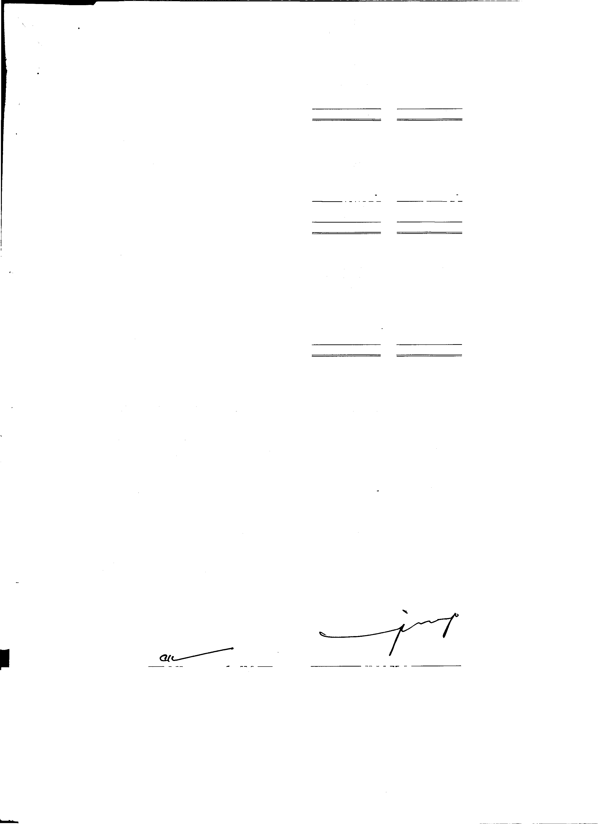

These interim condensed Financial statement have been authorised for issue on January 13, 2016 by the Board of

Directors of the company.

15. GENERAL

Figures have been rounded *off* to the nearest rupee:

-

Lahore,

January 13, 2016 CAl�ITTIVE DIREC I OR